Second Semester
CSE
CS3401 - Model Examination
(Regulation 2023)
Time: Three Hours | Maximum Marks: 100 Marks
 | PART- A | (10 x 2 = 20 Marks)
Q.No. | Answer ALL Questions | CO | BTL | Marks
1 | Modulus of elasticity is defind as the ratio of ? Justify your answer? a) Shear stress to shear strain b) Linear stress to linear strain c) Linear strain to lateral strain d) Lateral strain to linear strain | CO1 | 1 | 2
2 | Analyze the stress distribution in a compound bar made of two different materials subjected to axial load. | CO1 | 4 | 2
3 | False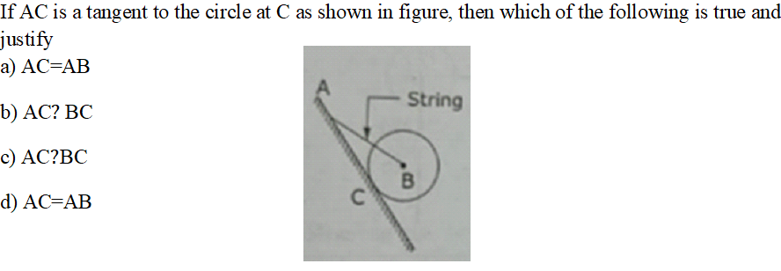 | CO2 | 1 | 2
4 | Contrast the parallelogram law of forces | CO2 | 2 | 2
5 | The angular displacement of a body in rotational motion is measured in: Justify.  a) meters  b) degrees  c) radians  d) revolutions per minute | CO3 | 4 | 2
6 | Releat the range of a projectile in parabolic curve of curvilinear motion. | CO3 | 4 | 2
7 | Which theorem is used to calculate the Moment of Inertia of a composite area about its final centroidal axis by transferring the Moment of Inertia of its constituent parts? Justify your answer. a) Parallel Axis Theorem b) Perpendicular Axis Theorem c) Principle of Superposition d) Moment of Area Theorem | CO4 | 4 | 2
8 | Analyze the basic elements of truss and their types. | CO4 | 4 | 2
9 | The bending moment diagram for a cantilever beam under UDL is: Justify your answer.  a) Linear  b) Parabolic  c) Cubic  d) Constant | CO5 | 4 | 2
10 | Examine how modulus of rupture helps in predicting the failure mode of a shaft under torsional loading. | CO5 | 4 | 2
 | PART- B | (5 x 16 = 80 Marks)
Q.No. | Answer All Questions | CO | BTL | Marks
11 a | Analysis of a given problem with solution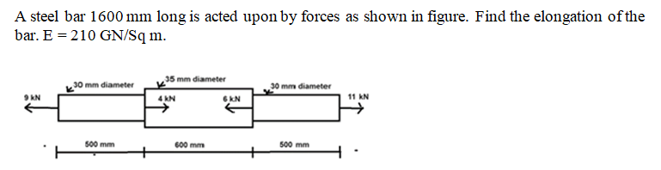 | CO1 | 3 | 16
(OR)
11 b | Two vertical rods, one of steel and the other of bronze, are rigidly fastened at upper ends at a horizontal distance of 760mm apart. Each rod is 3m long and 25mm in diamter. A horizontal cross-piece connects the lower ends of the bars. Where should a load of 4.5kN be placed on the cross-piece so that it remains horizontal after being loaded? Determine the stresses in each rod. Given Young's modulus of steel=210GN/m², Young's modulus of bronze=112.5GN/m². | CO1 | 3 | 16
12 a | Application problems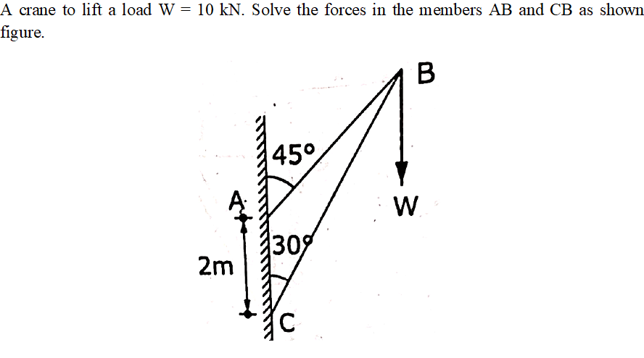 | CO2 | 3 | 16
(OR)
12 b | Application problems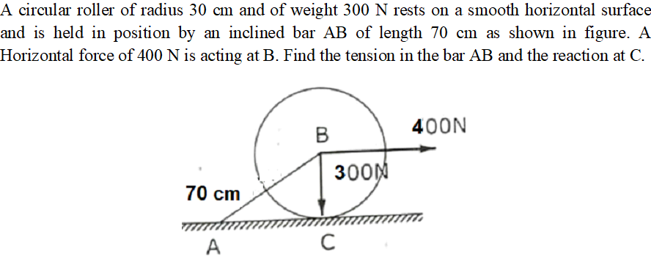 | CO2 | 3 | 16
13 a | The equation of motion of a particle is given, acceleration (a) in terms of time (t) as below. a =3t² + 2t +4, in which acceleration is in m/s² and time t is in seconds. It is observed that the velocity of the particle is 12 m/s after 4 seconds; and the displacement of the particle is 8 m after 4 seconds. Determine (i) Velocity after 6 seconds (ii) Displacement after 4 seconds | CO3 | 4 | 16
(OR)
13 b | A particle is projected with an initial velocity of 50 m/s at an angle of 65° with the horizontal. Analyze the following  i) Maximum height attained by the particle  ii) Horizontal range of the particle  iii) Time taken by the particle to reach highest point  iv) Time of flight | CO3 | 4 | 16
14 a | Calculation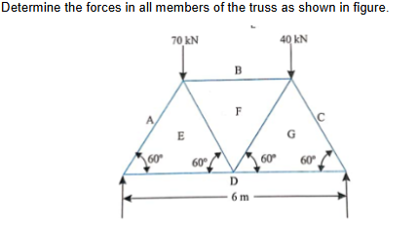 | CO4 | 3 | 16
(OR)
14 b | Calculation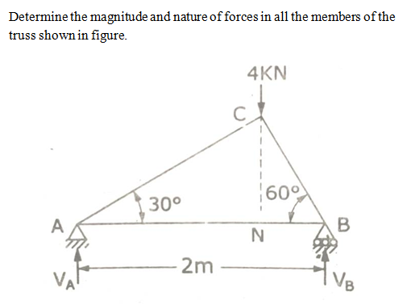 | CO4 | 3 | 16
15 a | Draw the shear force diagram and bending moment diagram for a simply supported beam of length 9m and carrying a uniformly distributed load of 10kN/m for a distance of 6m from the left end. Also calculate the maximum bending moment on the section. | CO5 | 3 | 16
(OR)
15 b | Derive an expression for the power transmitted by a circular shaft and show how torque and speed affect it. | CO5 | 3 | 16

******************
QP123

